CO1-AT1
N.NAVEENKUMAR
Reg NO : 192372341
1.Library management system
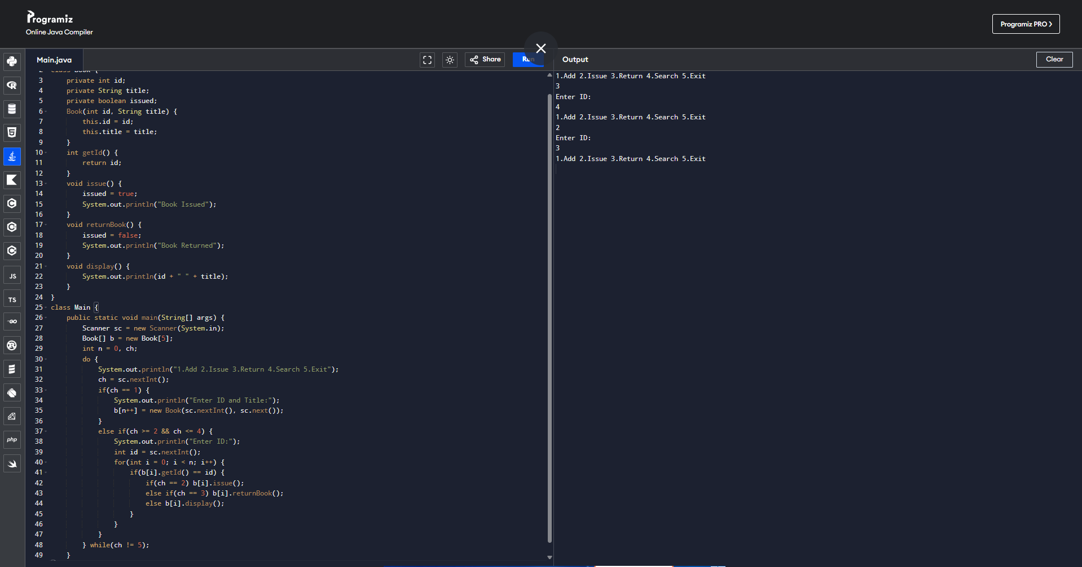

2. Employee Payroll System
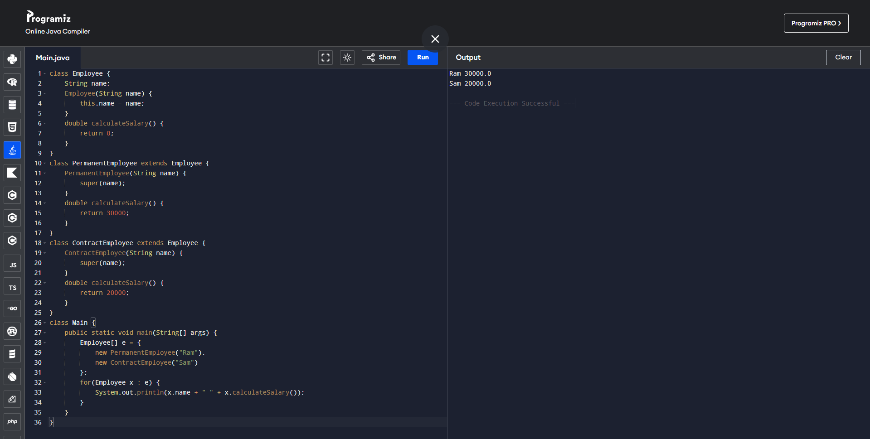

3. Vehicle Rental System
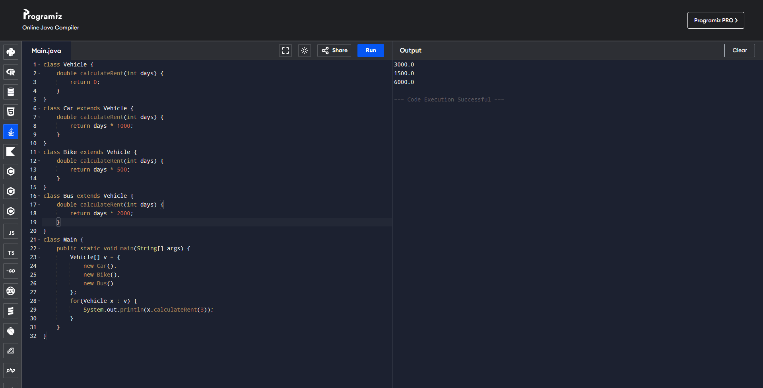

4. Bank Account System
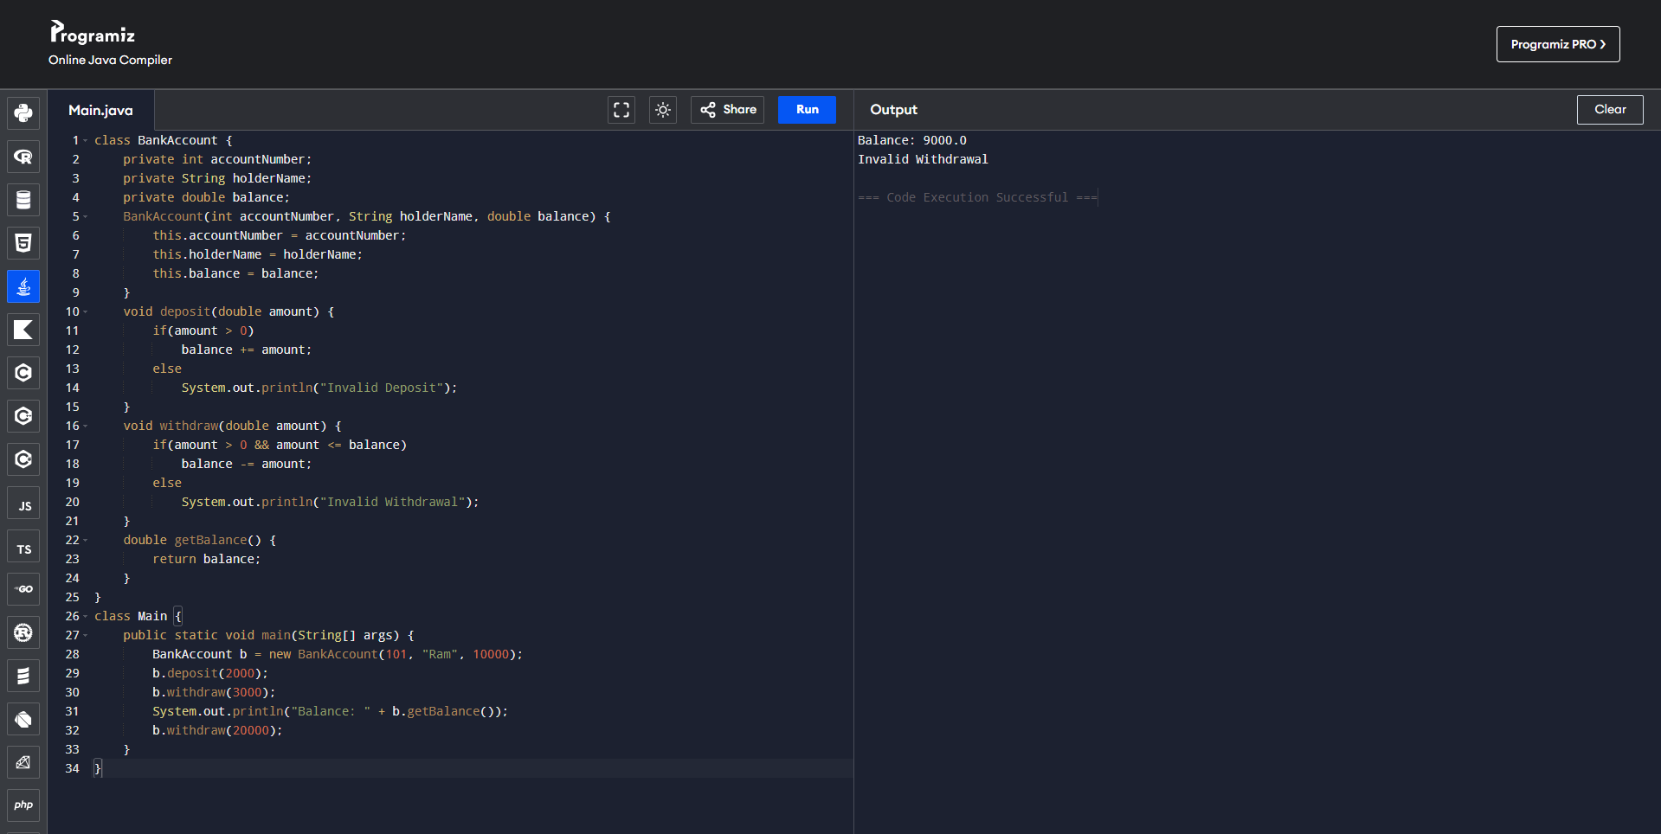

5. University Admission System
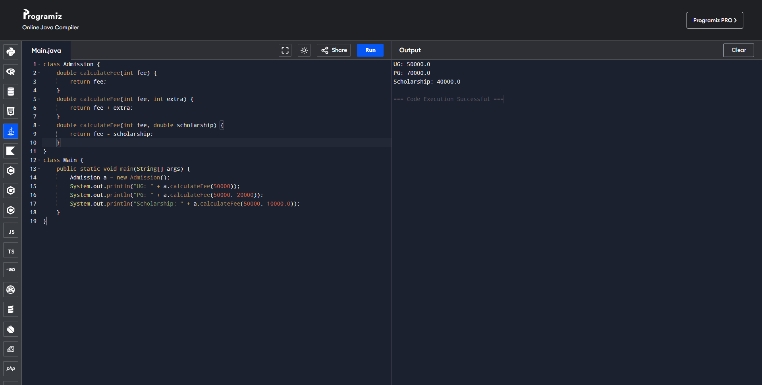

6. Shape Area Calculator
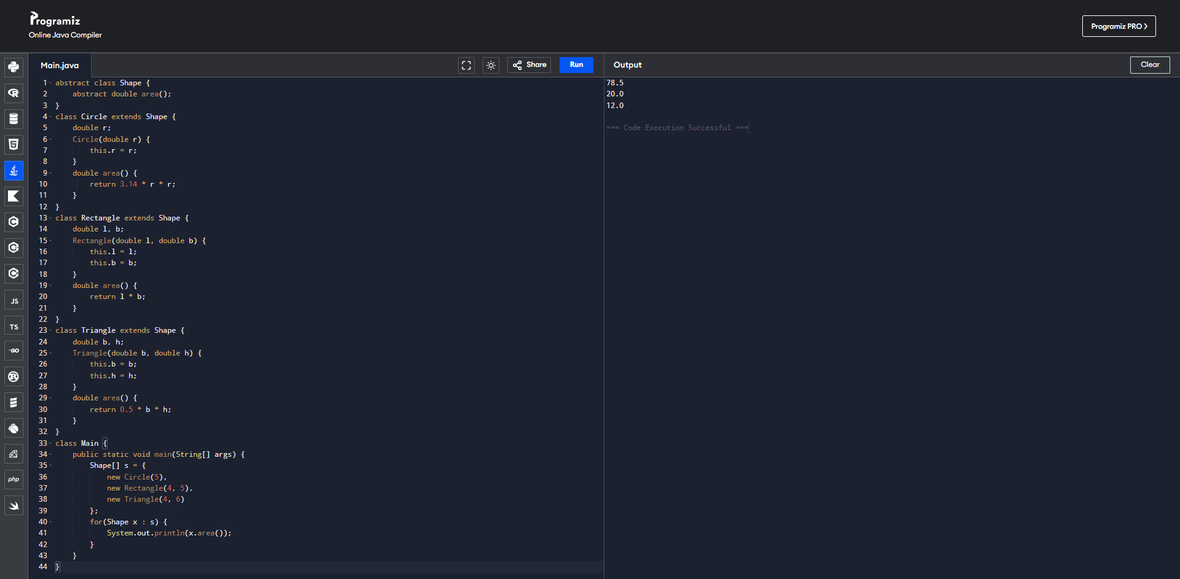

7. Hospital Management System
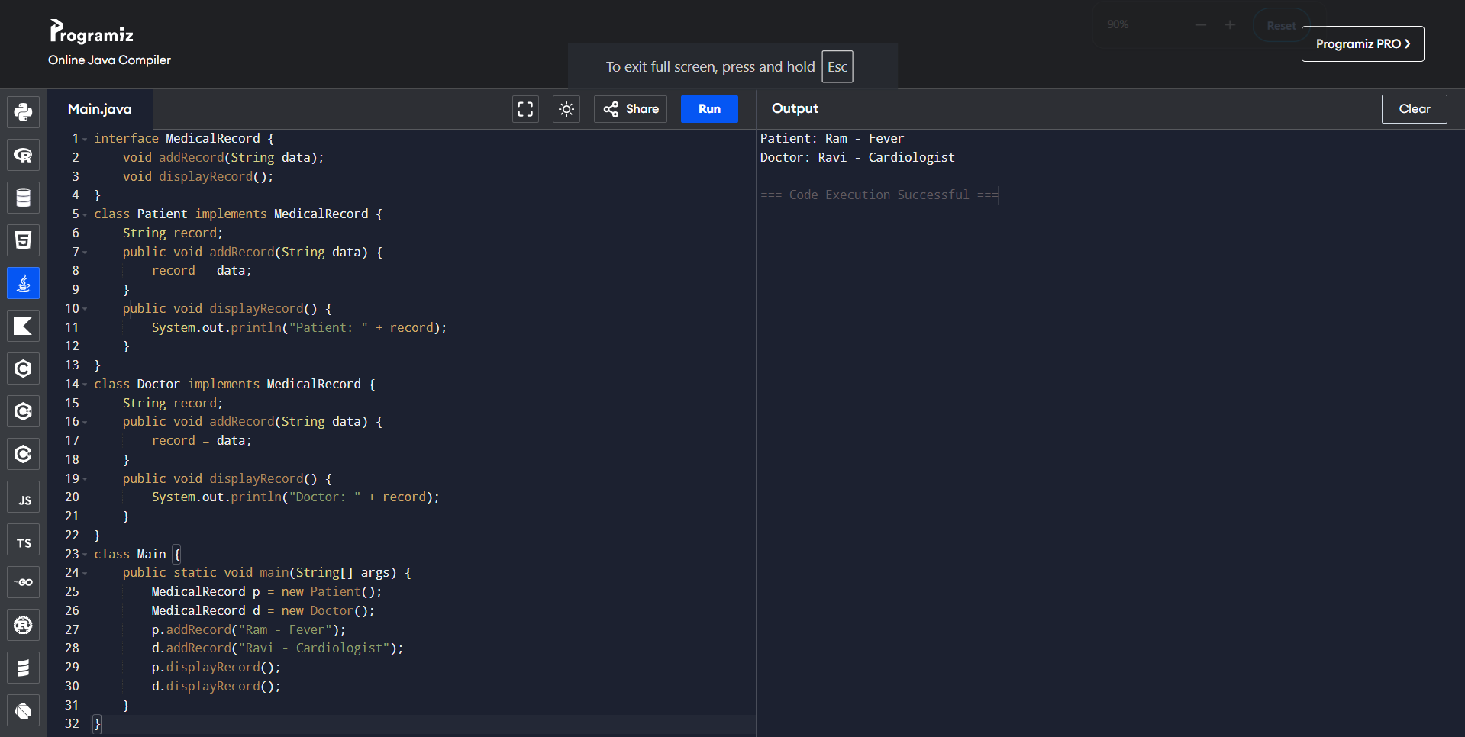

9. Student Result Analyzer using Arrays of Objects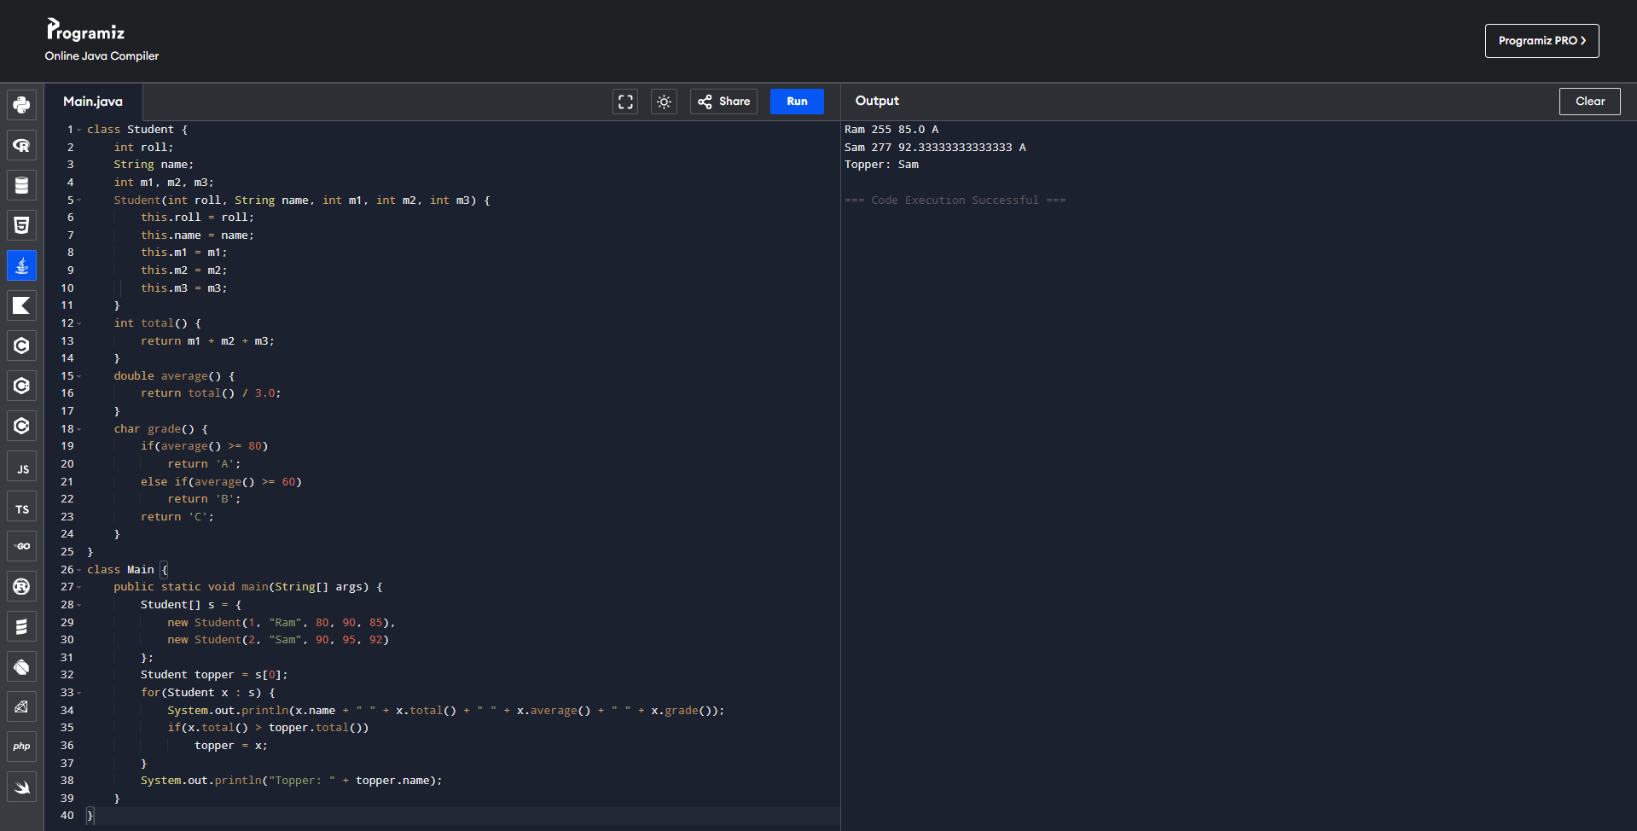

10. Smart Home Device Controller using Hierarchical Inheritance
